Twizzle Phase 2 Report Draft
1. Project Overview
Twizzle is a social media platform that started as a pure front-end Phase 1 application using HTML, CSS, vanilla JavaScript, and localStorage. In Phase 2, the application was upgraded to use a real relational database with Prisma, Next.js API routes, and a new analytics page built with Next.js and React.
2. Data Model
The application data was normalized into five relational entities:
- User
- Post
- Comment
- PostLike
- Follow
Schema
User connects to Post, Comment, PostLike, and Follow. Post connects to Comment and PostLike.
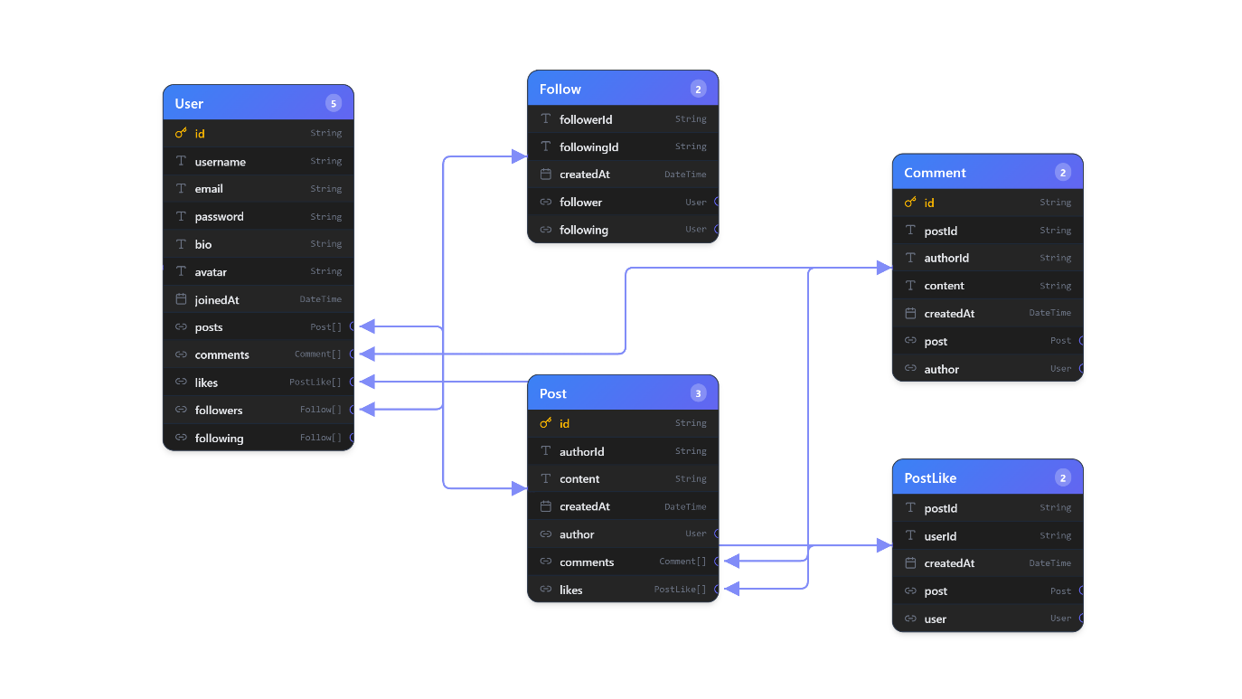
Entity Summary
- User: stores account information, bio, avatar URL, and join date.
- Post: stores message content and the author who created it.
- Comment: stores replies attached to a post and the user who wrote each reply.
- PostLike: stores many-to-many post likes between users and posts.
- Follow: stores many-to-many follow relationships between users.
3. Database Initialization and Seed Data
The original Phase 1 seed content was extracted into JSON files:
- data/users.json
- data/posts.json
The seed implementation is in prisma/seed.cjs.
It performs these steps:
- Clears old rows.
- Inserts users.
- Inserts follow relationships.
- Inserts posts.
- Inserts comments.
- Inserts likes.
4. Repository
The application now uses repository modules instead of browser localStorage:
- lib/repositories/user-repository.js
- lib/repositories/post-repository.js
- lib/repositories/stats-repository.js
These repository functions handle:
- login and registration
- loading the signed-in user
- feed loading
- explore search
- profile loading
- follow/unfollow
- post creation and deletion
- likes and comments
- statistics queries
All filtering, sorting, and aggregation are pushed into Prisma queries so the database performs the work instead of the browser.
5. Next.js API Routes
The Phase 1 UI now calls database-backed Next.js APIs:
- POST /api/auth/login
- POST /api/auth/register
- GET /api/users/me
- GET /api/users/explore
- GET /api/users/suggestions
- GET /api/users/[userId]
- PATCH /api/users/[userId]
- POST /api/users/[userId]/follow
- GET /api/posts/feed
- POST /api/posts
- GET /api/posts/[postId]
- DELETE /api/posts/[postId]
- POST /api/posts/[postId]/like
- POST /api/posts/[postId]/comments
The route handlers are located under app/api.
6. Statistics Use Case
The analytics page is implemented at app/stats/page.js. This page is built with Next.js and React and reads statistics through Prisma queries from lib/repositories/stats-repository.js.
Statistics Implemented
At least six statistics were required. This implementation includes:
- Total registered users
- Total published posts
- Average followers per user
- Average posts per user
- Average comments per post
- Average likes per post
- Most followed user
- Most active user in the last 90 days
- Most liked post
- Most discussed post
Example Query Types Used
- count() for totals such as users, posts, comments, likes, and follows
- findFirst({ orderBy: { relation: { _count: 'desc' } } }) for top user/post lookups
- groupBy() for identifying the most active authors
- relation filters such as some, none, and nested where conditions

7. Setup and Run Instructions
- open an integrated terminal in the project folder
- Run npm i
- Run npm run db:generate
- Run npm run db:migrate
- Run npm run db:seed
- Run npm run dev
- Open the localhost link to open the application
Demo login:
- Email: dana@example.com
- Password: password123
Or you can create a new account instead.
8. Conducted Tests
The following checks were completed during implementation:
- Prisma client generation completed successfully.
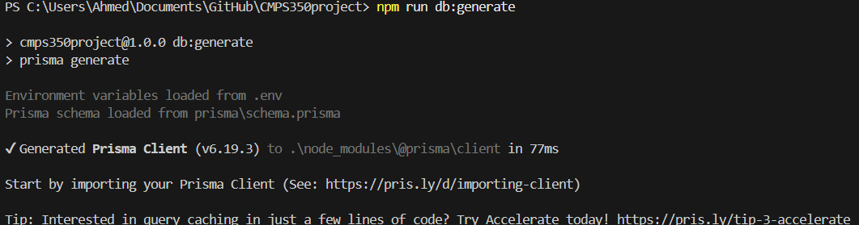
- Database bootstrap script created the SQLite database.
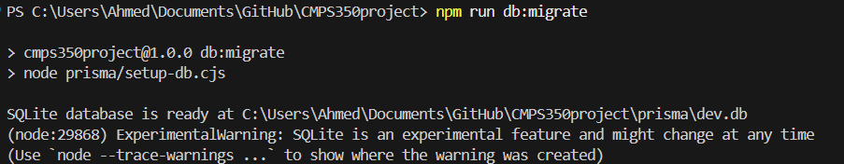
- Seed script populated the database.
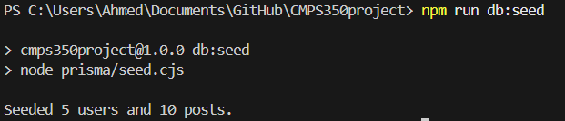
- App running
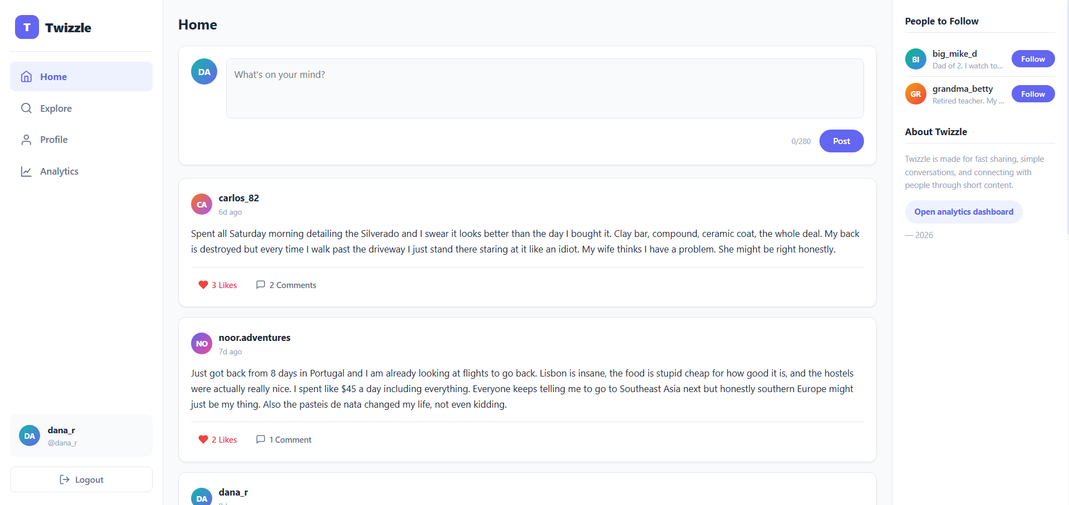
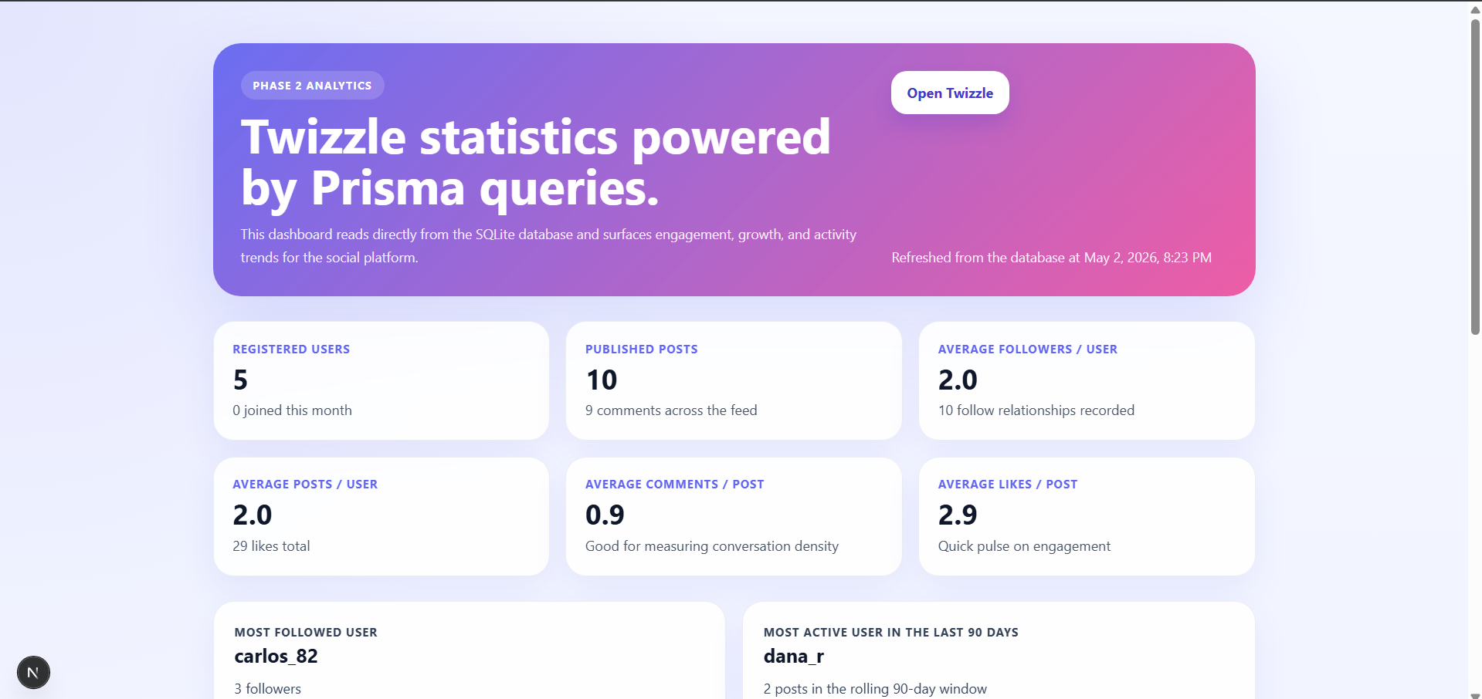
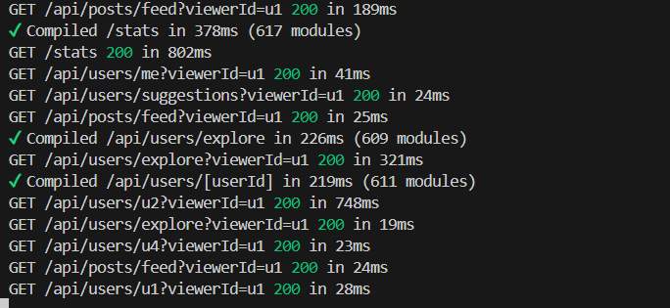

9. Contribution Section
- Ahmed Laghdaf: 25%
- Abdulrahman Alajbar: 25%
- Jassim Alanbari: 25%
- Maher Alwajih: 25%

